**Leader Overview**

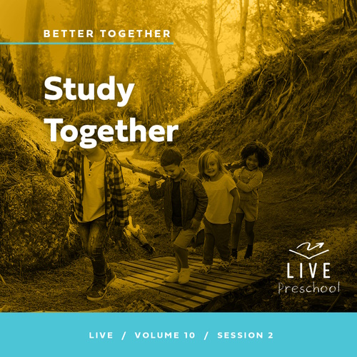

**Volume Overview**

**Better Together**

*The Christian life is never lived alone. When we become a Christian, we’re adopted into God’s family. We’re welcomed into a community. We’re meant to live and grow in faith together. But that takes humility and intentionality. We grow together as we pray and study Scripture together. We bear responsibility for one another by our encouragement and our honoring of those in authority. God is growing us together as one body, one family.*

**Session Overview**

**Study Together**

*In this* **Live** *session, preschoolers will explore how the people in Berea heard teaching and then searched the Scriptures for truth. Kids will discover that they can learn and grow in faith with others, and that we can celebrate coming to church to study God’s Word together.*

**Bible Lesson**

The Bereans Eagerly Search the Scriptures

[Acts 17:10–15](https://ref.ly/logosref/Bible.Ac17.10-15)

**Faith Fact**

We can grow and learn together.

**Faith Verse**

[Ephesians 4:3](https://ref.ly/logosref/Bible.Eph4.3) (NLT)

Make every effort to keep yourselves united in the Spirit, biding yourselves together with peace.

**Preparing for the Session**

**Leader Preparation Time: 20–25 Minutes**

|  |
| --- |
| ***You Will Need***  ***Preservice Activities***  *• Toys*  *• Magnifying glass*  *• Leader’s choice snack*  ***Large Group***  *• Bible*  *• Worship songs (Song suggestions: “Alive with You” Lyric Video by Gateway Kids Worship; “I Need You” Lyric Video by Gateway Kids Worship; “Good to Me” Lyric Video by Elevation Church Kids*  *• For groups not using a phone or tablet only, add:*  *• Projector or TV*  *• Laptop*  *•* ***Faith Fact Sound*** *video (bell ringing)*  ***• Faith Fact Slide***  *•* ***Faith Verse Slide***  *•* ***Faith Verse Video***  *•* ***Bible Lesson Video A***  ***• Bible Lesson Video B***  ***Small Group***  *• Small toy or stuffed animal*  *•* ***Small Group Activity Page****, one per kid*  *• Crayons or markers*  *• Yarn cut into 12” lengths, one piece for every two kids*  *• Scissors*  *• Cones or bottles of water*  *• Bible*  *• Folding chair, one per group*  *To access session content and videos from a computer, visit:* [***BibleEngagementProject.com/downloads***](https://bibleengagementproject.com/downloads) |
| ***Getting Ready***  ***Preservice Activities***  *• Set out toys and snacks.*  ***Large Group***  *• Download videos and slides if needed.*  *• Select worship song(s) and have them ready to play.*  ***Small Group***  *• Print copies of the Small Group Activity Page, one per kid.*  *• Create a small obstacle course using cones or bottles of water.*  ***First time leading* Live *for Preschool? Check out the*** [**Facilitator Guide**](https://0b769b0ed3569ef9d18b-f88d8272f61086866d50d048b43ef630.ssl.cf2.rackcdn.com/sites/biblengagementproject/Listen_Facilitator_Guide.pdf)**.** |

**Preservice Activities**

*See what’s needed at the beginning of the session.*

**Bible Story Warm-Up**

Have you ever lost something? *(Group response)* Me too. It can be frustrating when we can’t find something we’re looking for. *(Hold up the magnifying glass.)* This can help us find things. Can anyone tell me what this is called? *(Allow responses.)* It’s a magnifying glass. When you look through it, it changes the way things look. Does anyone want to look through it? *(Group response)*

• *Pass the magnifying glass around the group.*

Did things look bigger or smaller when you looked at them through the magnifying glass?

Do you think it would help us find things?

What is something you’ve had to look for?

Today, we’ll learn that searching for things isn’t just about finding lost things. It can also be about finding new things. This will be a great day of learning more about God’s Word, and I’m super excited that we get to do it together.

**Snack**

**Leader’s Choice Snack**

How many of you like to learn new things? *(Group response)* Today, we’ll talk about learning together. Let’s share about things we’re learning while we eat a snack together.

• *Hand out snacks.*

As we eat, tell me one new thing you’ve learned to do or something that you want to learn to do.

• *Give kids time to share.*

I’m excited that you like to learn new things. I can’t wait to learn more with you today.

**Free Play**

*Any extra time can be spent playing with toys.*

**Transition**

*A few minutes before service begins have kids make their way to the large group area and sit in their designated areas.*

**Large Group**

**25 Minutes**

*See what’s needed at the beginning of the session.*

**Introduction**

Hi, friends! It’s so great to be here with you today! I love exploring God’s Word together. *(Hold up the Bible.)* Together is an important word. It means that we don’t have to do things alone. If you love coming to church with friends, give me your hugest wave! *(Group response)*

Today, we’ll learn about a group of people in the Bible who searched God’s Word and found His truth together. They were from a town called Berea. Can you say, “Berea,” with me? *(Group response)* We’ll celebrate the fact that we can come to church and learn God’s truth with other friends.

**Faith Fact**

When we study the Bible together like we’re doing right now, then we’re doing what the Bible tells us to do. That’s our Faith Fact today. **We can learn and grow together.**

• *Show the* ***Faith Fact Slide.***

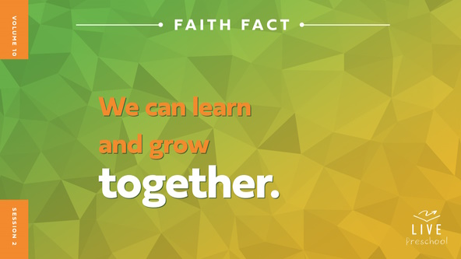

When we say it the first time, let’s whisper it quietly. **We can learn and grow together**. Great! This time point to a friend next to you while you say it. **We can learn and grow together**.

**Bible Time**

What do you think the word *learn* in our Faith Fact means we’re learning about? *(Allow responses.)* We can learn about many things. Most importantly, we can learn about God and His Word. We have a friend who helps us learn from the Bible together. Let’s see what Lizzy is doing.

• *Play* ***Bible Lesson Video A****.*

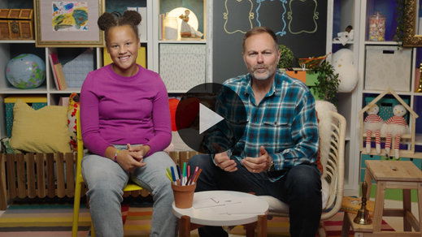

What a great question about our Bible story! Let’s think about the answer and spend some time worshipping God.

**Worship**

When we worship God, we get to tell Him how amazing He is. Worship is a great time to focus on all the things we know and love about God.

**Praise**

Who wants to thank God for giving us friends to grow with? Fist bump with a friend or two. *(Group response)*

Are you glad God shows us truth in His Word? Say, “Oh, yeah!” *(Group response)*

Who is happy we can come to church to learn together? Clap your hands three times. *(Group response)*

**Sing**

Now, let’s worship God by singing. God loves it when we do that together.

• *Lead the kids in singing one or two songs. See song suggestions at the beginning of the session.*

**Prayer**

God is so good to us. He loves us very much. Let’s bow our heads and talk to God.

|  |
| --- |
| *Dear God, You are so good to us. Thank You for giving us friends to grow with. Thank You that we can come to church to learn more about You. We love You. Amen.* |

**Bible Time cont’d**

It’s almost time for Grandpa and Lizzy to come back. Let’s think about the answer to what happens next in our Bible story. Put on your thinking cap *(demonstrate)*. What do you think? Did the people at Berea search the Scriptures for truth? *(Point to Bible graphic on the screen.)* Or did they close their ears and minds to Paul’s message? *(Point to the X over ear graphic on the screen.)*

If you think the people in Berea searched the Bible for truth, hold your hands out like you’re reading a Bible. If you think they closed their ears and hearts to Paul’s message, cover your ears with your hands. Ready? Choose your answer.

• *Pause while kids respond.*

Let’s find out if you’re right! Let’s check back in with Lizzy and Grandpa.

• *Play* ***Bible Lesson Video B.***

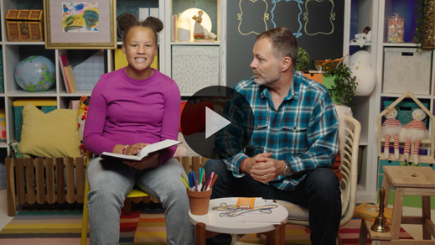

**Response Time**

*Play a worship song quietly.*

What a great example the people at Berea gave us. They searched the Bible for truth and found it. God is faithful to teach us His truth when we ask Him. Let’s respond to what we’ve learned today. Hold out your hands like you’re about to get a present because that’s what God’s truth in the Bible is for us.

• *Have the kids repeat phrases of the prayer after you.*

|  |
| --- |
| *Dear God, I want to learn and grow in Your truth. Give me Your wisdom. Show me who You are. You are so, so good to me. Amen.* |

**Faith Verse**

God’s truth is found in His Word, so He loves it when we learn Bible verses from His Word. Let’s say our Faith Verse and do the actions together.

[Ephesians 4:3](https://ref.ly/logosref/Bible.Eph4.3) (NLT)

Make every effort to keep yourselves united in the Spirit, binding yourselves together with peace.

• *Play* ***Faith Verse Video****.*

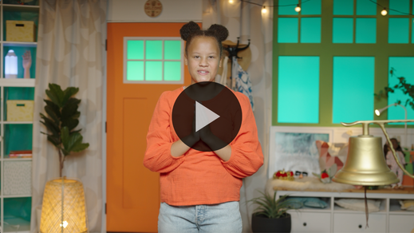

**Ephesians** *(hands at waist, spread apart, palms up and out)*

**4:** *(hands together like a clap)*

**3** *(hands opened to “book”)*

**Make every effort** *(sweep hands out and to the sides)*

**to keep yourselves united** *(bring hands together in a clap)*

**in the Spirit,** *(clap twice with the syllables of “Spirit”)*

**binding yourselves together** *(wrap arms around like a hug)*

**with peace.** *(bow head and whisper)*

**Closing**

I’ve had such a great time with all of you today! We’ve learned more about God and His truth today. Who remembers the name of city we heard about in our Bible story? *(Allow responses.)* Berea! Some of the people there loved to study God’s Word together.

What was your favorite thing we did today? *(Allow responses.)* It’s a joy to come here with all of you so that we can learn and grow together.

• *Play the* ***Faith Fact Sound*** *video (bell ringing).*

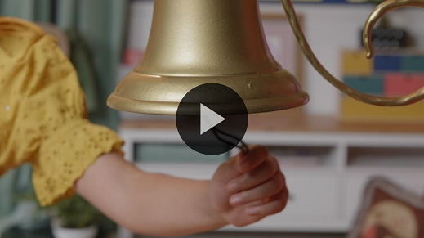

That sound means it’s time to say our Faith Fact again. **We can learn and grow together**.

• *Show the* ***Faith Fact Slide.***



Link arms with the friends next to you while we say it. **We can learn and grow together**. Let’s shout it! **We can learn and grow together.**

**Dismissal to Small Groups**

Now, you get to do something very special. It’s time to go to our small groups where you can continue to learn and grow together with your friends.

• *Dismiss the kids by groups.*

|  |
| --- |
| ***Leader Tip:*** *This can be done by assigning color teams or by age groups. Note that some young preschoolers may not know their age. Using a colored sticker, jersey, or wristband will help separate the kids and help identify their small groups.* |

**Small Group**

**25 Minutes**

*See supplies and prep instructions at beginning of session or in each activity below.*

|  |
| --- |
| ***Leader Tip:*** *Small groups can alternate to each circle, or all groups can do each activity at the same time. If you choose to alternate, you will need at least one leader per circle.* |

**Circle 1**

**Group Connection**

**Seek and Find**

|  |
| --- |
| ***You Will Need***  *• Small toy or stuffed animal*  *No prep needed for this activity.* |

Our Faith Fact has taught us that **We can learn and grow together**. In our Bible story, the Bereans searched God’s Word to learn together. Learning is fun, and it’s way more fun when we get to do it together. We can also search while playing a game. Does anyone want to do that? *(Group response)* Perfect.

The way this game works is simple. *(Hold up the item to hide.)* I’ll choose someone in our group to hide this while everyone else closes their eyes. Then, when I say, “Go,” everyone will search for it together. Are you ready to give this a try? *(Group response)* Before we start, let’s say our Faith Fact together. **We can learn and grow together**. Okay, let’s play.

• *Choose someone to hide the toy and have everyone else close their eyes.*

• *Play as many rounds as time permits.*

That was incredible! You searched great together! My prayer today is that you never forget that learning new things from the Bible is the best thing we could ever search for. **We can learn and grow together** and have fun while doing it.

**Circle 2**

**Activity Page Time**

**Find the Bibles**

|  |
| --- |
| ***You Will Need***  *•* ***Small Group Activity Page****, one per kid*  *• Crayons or markers*  ***Getting Ready***  *• Print copies of the* ***Small Group Activity Page****, one per kid.* |

In our Bible story, we learned that the Bible is filled with many promises and stories that reveal who God is. The more time we spend studying what’s in the Bible, the better we will know God.

The great thing is we don’t have to study the Bible alone. We can study with our friends and family just like the people in Berea did. Our Activity Page will help us remember this. Before I explain how your Activity Page works, let’s say our Faith Fact together one time. Ready? **We can learn and grow together**. Great job!

• *Hand out a copy of the* ***Small Group Activity Page*** *and crayons to each kid.*

On your Activity Page, you will see a lot of people together. Hidden in this picture are ten Bibles. Your job is to find all the Bibles and circle them. You can only see part of the Bibles, so you will need to search carefully. Then you can color the rest of the picture.

• *Allow kids time to complete the activity. Help them as needed.*

• *During the activity, interrupt and practice the Faith Fact:* **We can learn and grow together.**

• *Play the* ***Faith Fact Sound*** *video. Review the Faith Fact even if you can’t play the sound.*



**Circle 3**

**Feet-to-Floor Game Time**

**Go Together**

|  |
| --- |
| ***You Will Need***  *• Yarn cut into 12” lengths, one piece for every two kids*  *• Scissors*  *• Cones or bottles of water*  ***Getting Ready***  *• Create a small obstacle course using cones or bottles.* |

Is everyone ready to play a game? *(Group response)* Awesome! I love playing games, and this one will be extra special because you get to play it with a partner. In order to play, you and a partner will have to be in sync. That means you’ll have to work together and move like you’re one person. Wait! That reminds me of the Bible verse we’ve been learning. Does anybody remember our Faith Verse? *(Allow responses.)* Let’s say it together one time.

• *Repeat the verse together.*

[Ephesians 4:3](https://ref.ly/logosref/Bible.Eph4.3) (NLT)

Make every effort to keep yourselves united in the Spirit, binding yourselves together with peace.

Great job! For our game, you and your partner will have to make your way through an obstacle course. *(Demonstrate the path.)* There’s only one catch. You will be connected together. When it’s your turn, you’ll both hang onto one end of a piece of yarn. That means you both have to move at the same time in the same direction. You’ll have to work together.

If you’re ready to play, say our Faith Fact. **We can learn and grow together.** Amazing! Let’s go!

• *Give kids the pieces of yarn.*

• *Allow them to make their way through the obstacle course as many times as time permits.*

• *To increase difficulty, you can change how they travel through the obstacle course (e.g., hopping, skipping, crawling).*

That was awesome! You did such a great job working together. Before we go to our next circle, let’s say our Faith Verse together one more time.

• *Lead kids through the Faith Verse with actions.*

**Ephesians** *(hands at waist, spread apart, palms up and out)*

**4:** *(hands together like a clap)*

**3** *(hands opened to “book”)*

**Make every effort** *(sweep hands out and to the sides)*

**to keep yourselves united** *(bring hands together in a clap)*

**in the Spirit,** *(clap twice with the syllables of “Spirit”)*

**binding yourselves together** *(wrap arms around like a hug)*

**with peace.** *(bow head and whisper)*

**Circle 4**

**Hands-On Learning**

**Chair Object Lesson**

|  |
| --- |
| ***You Will Need***  *• Bible*  *• Folding chair, one per group*  *No prep is needed for this activity.* |

Today has been such a fun day! We discovered the truth that we can learn more about God together. The best part about that is we don’t have to learn alone. I want to tell you more about that, but I don’t want to do it alone. I need someone to help me with this next part.

• *Choose a volunteer and have the kid stand by a folding chair that is folded up.*

My friend has a chair. Go ahead and sit down. *(As the volunteer begins to open the chair to sit down, stop them.)* Whoa! What are you doing? I told you to sit down. I didn’t tell you to open the chair. I just want you to sit on it. Go ahead and do that now.

• *Give the volunteer and group time to tell you it’s impossible.*

It’s impossible to do what I said without opening the chair. How can you sit down on a closed chair? That would be silly. Did you know the same is true with God’s Word? *(Hold up the Bible.)* If we never open the Bible and study it, we won’t know what God wants us to know and do.

*(To volunteer)* I said you’re not allowed to open your chair to sit down, but I want you to sit on it. What could you do to make that happen? *(Allow responses.)*

• *If needed, hint to kids that a friend could help unfold the chair.*

• *Have the volunteer choose someone to help with the chair.*

When you worked together, you learned that even though you weren’t allowed to open the chair, someone else could open it for you. When we decide to read God’s Word and let others join us, we grow together. When we do things together, it’s so much better than doing them alone.

**Dismissal**

• *Play the* ***Faith Fact Sound*** *video (bell ringing).*



• *Show the* ***Faith Fact Slide.***



We’ve had a lot of fun learning and growing together. Before we go, let’s say the Faith Fact together one last time. **We can grow and learn together.** Great job! I had a great time learning more about God’s Word with you. See you next time!

• *Send home the* ***Small Group******Activity Page*** *with each kid.*

• *Remind parents that there are* ***Family Devotions*** *available on the app to do with their kid.*

• *Tell everyone the date and time for the next session.*